Smartwatch Sentiment Analyzer: Uncovering Customer Sentiments

Project Description
The Smartwatch Sentiment Analyzer is an intelligent Natural Language Processing (NLP) based application designed to analyze and classify customer reviews of the ABC X1 Smartwatch as Positive, Negative, or Neutral. The system uses the TextBlob library for sentiment analysis and a Streamlit-based web interface for real-time interaction.
By examining the emotional tone and polarity of customer feedback, the system helps companies understand user satisfaction, identify product strengths and weaknesses, and improve overall product quality. This project provides a fast, accurate, and user-friendly solution for analyzing customer opinions without the need for manual review.

Project Scenarios

Scenario 1: Online Product Review Analysis
A customer submits a review on an e-commerce platform after purchasing the ABC X1 Smartwatch.
The Smartwatch Sentiment Analyzer instantly analyzes the review and classifies it as positive, negative, or neutral.
This helps the company quickly understand overall customer satisfaction and respond to negative feedback efficiently.

Scenario 2: Marketing and Product Improvement Strategy
The marketing team collects multiple smartwatch reviews from different users.
By entering these reviews into the Smartwatch Sentiment Analyzer, the system quickly identifies common positive features and recurring complaints.
This enables the company to improve future smartwatch models and design better marketing strategies.

Scenario 3: Customer Support and Complaint Management
A customer contacts customer care with feedback regarding battery life, display performance, or features.
The support team enters the message into the Smartwatch Sentiment Analyzer to instantly understand the customer's emotional state.
Based on the sentiment result, the issue is prioritized and handled appropriately to improve customer satisfaction.

Technical Diagram:

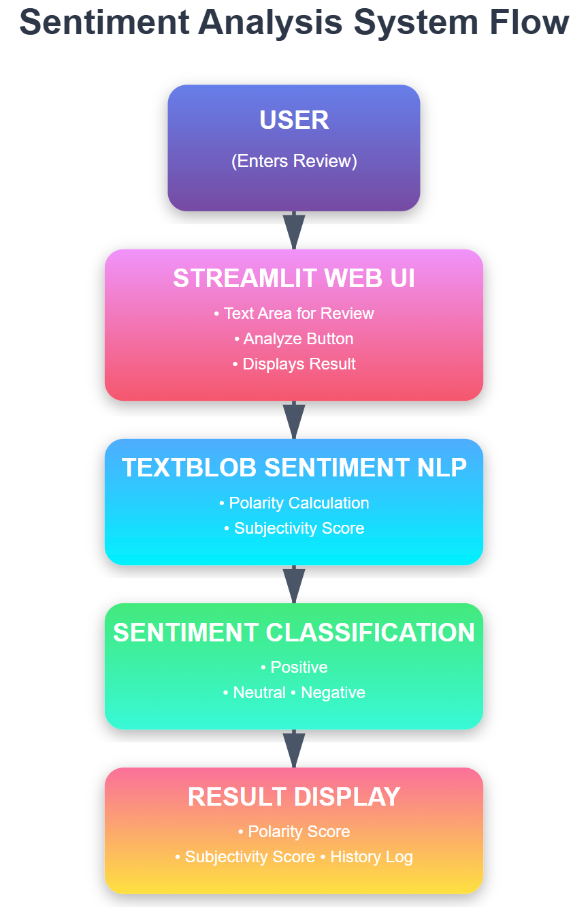

Project Flow
- User enters a smartwatch review through the Streamlit web interface
- System preprocesses the input text by removing extra spaces and validating the input
- The TextBlob sentiment analysis engine analyzes the review
- Polarity and subjectivity scores are calculated
- Based on a predefined threshold, the system classifies the sentiment as Positive, Negative, or Neutral
- The final sentiment result along with polarity score is displayed to the user
- The system stores the analyzed review in the history section for future reference

Project Activities

1. System Setup & Input Preparation
- Setting up the Python development environment
- Installing required libraries such as Streamlit and TextBlob
- Designing the user input interface for entering smartwatch reviews
- Validating the user input before analysis

2. Text Processing & Sentiment Analysis
- Accepting real-time review input from the user
- Analyzing the sentiment using the TextBlob library
- Extracting polarity and subjectivity scores from the text

3. Sentiment Classification
- Defining threshold ranges for Positive, Neutral, and Negative sentiments
- Mapping polarity scores to appropriate sentiment labels
- Displaying sentiment results with clarity

4. Testing & Validation
- Testing the system using multiple types of reviews
- Validating results using positive, negative, and neutral test cases
- Checking system reliability and response behavior

5. Web Application Execution & Deployment
- Running the application using the Streamlit framework
- Deploying the project locally using the command streamlit run app.py
- Demonstrating real-time sentiment detection through the web interface

Project Structure
The Smartwatch Sentiment Analyzer project is organized in a simple and well-structured manner to ensure easy development, execution, and understanding of the system. The project folder contains the main application file required to run the sentiment analysis web application.

Project Folder Structure
Smartwatch Sentiment Analyzer/
│
├── app.py

Description of File
- app.py
This is the main Python file of the project. It contains:
  - The Streamlit web interface design
  - User input handling
  - Sentiment analysis logic using the TextBlob library
  - Sentiment classification into Positive, Negative, and Neutral
  - Result display and history tracking
This simple structure makes the project easy to execute and maintain. The application can be launched directly using the command:

Milestone : Data Collection & Preparation (Smartwatch Sentiment Analyzer)
Data collection is a fundamental step in sentiment analysis, as it provides the textual data required to analyze customer opinions and emotions. In the Smartwatch Sentiment Analyzer project, data refers to customer reviews of the ABC X1 Smartwatch. The quality and clarity of the collected reviews directly affect the accuracy of sentiment classification.
Unlike traditional machine learning projects that require large datasets for model training, this project focuses on real-time sentiment analysis using live user input. The reviews entered by users serve as the primary data source for analysis.

Activity 1.1: Collection of Smartwatch Reviews
There are several popular open sources for collecting product review data such as:
- Kaggle
- Amazon product reviews
- Flipkart user reviews
- Online e-commerce platforms
In this project, instead of downloading a large dataset for training, the system is designed to accept real-time smartwatch reviews directly from users through the Streamlit interface. This approach makes the application suitable for live customer feedback analysis.
However, for testing and demonstration purposes, sample reviews are manually entered to validate the correctness of the sentiment analyzer.

Understanding the Review Data
After collecting the review text from the user, the system performs basic input validation such as:
- Removing unnecessary spaces
- Checking for empty input
- Ensuring meaningful text is provided
Unlike numerical datasets, sentiment analysis deals with unstructured textual data, which represents customer opinions, emotions, and satisfaction levels.

Dataset Source (For Reference Only)
Since this project uses real-time user input, no fixed CSV dataset is required.
However, publicly available smartwatch review datasets can be obtained from:
- https://www.kaggle.com
- E-commerce review datasets from open repositories
These datasets can be used for future enhancements such as training machine learning models.

Features Used in This Project
The Smartwatch Sentiment Analyzer processes the following text-based features:
- Review Text: Customer feedback entered through the interface
- Polarity Score: Value between -1 and +1 indicating sentiment strength
- Subjectivity Score: Indicates whether the opinion is factual or emotional
- Sentiment Label: Final classification as Positive, Negative, or Neutral

Application Screenshots and Workflow

The workflow moves sequentially from data input to clinical risk assessment.

Home Page Interface

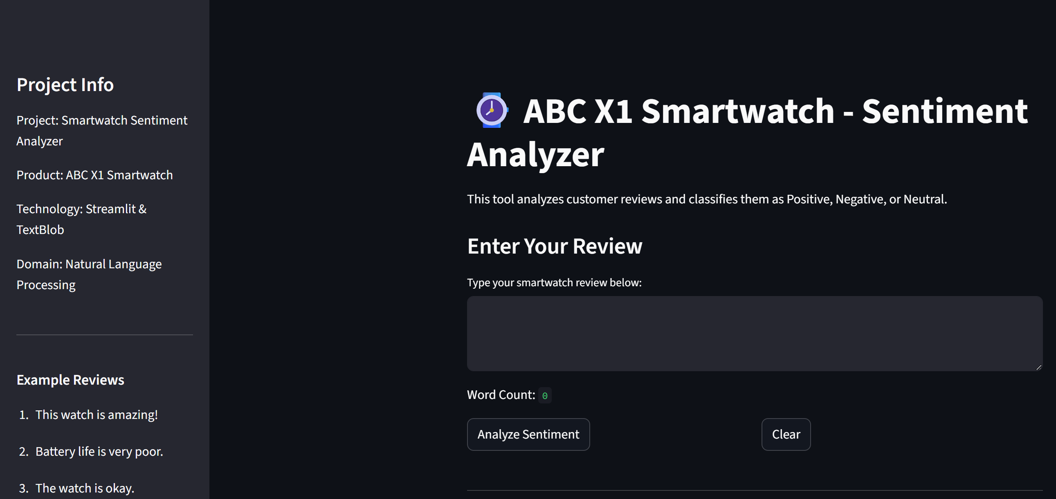2

- Reviews given by Smartwatch - Sentiment Analyzer

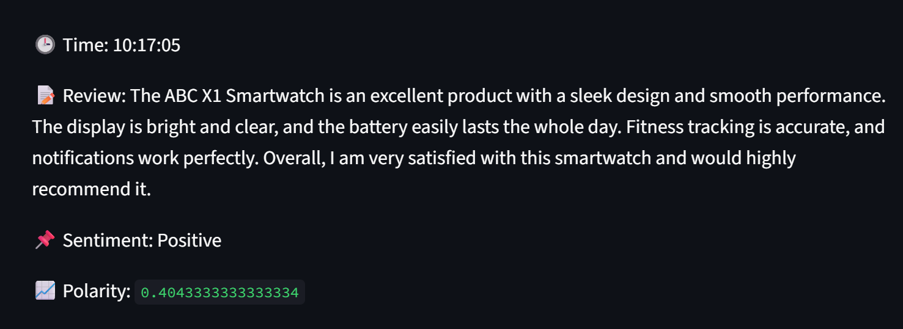

Positive Review

  - 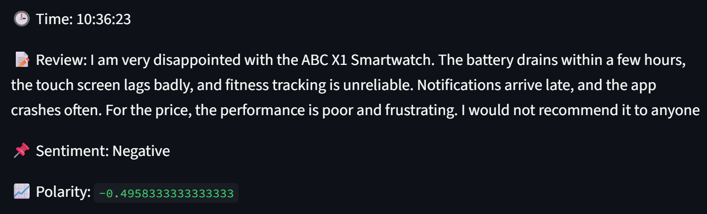

Negative review

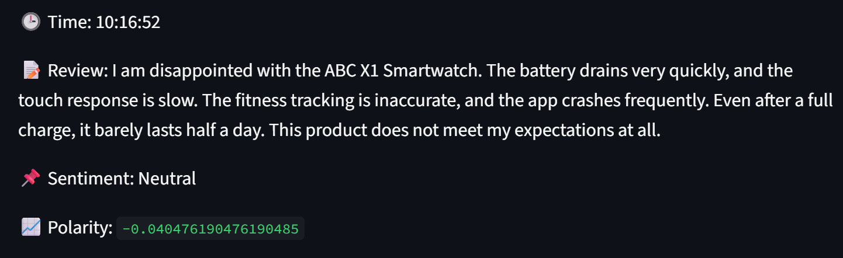

Neutral Review

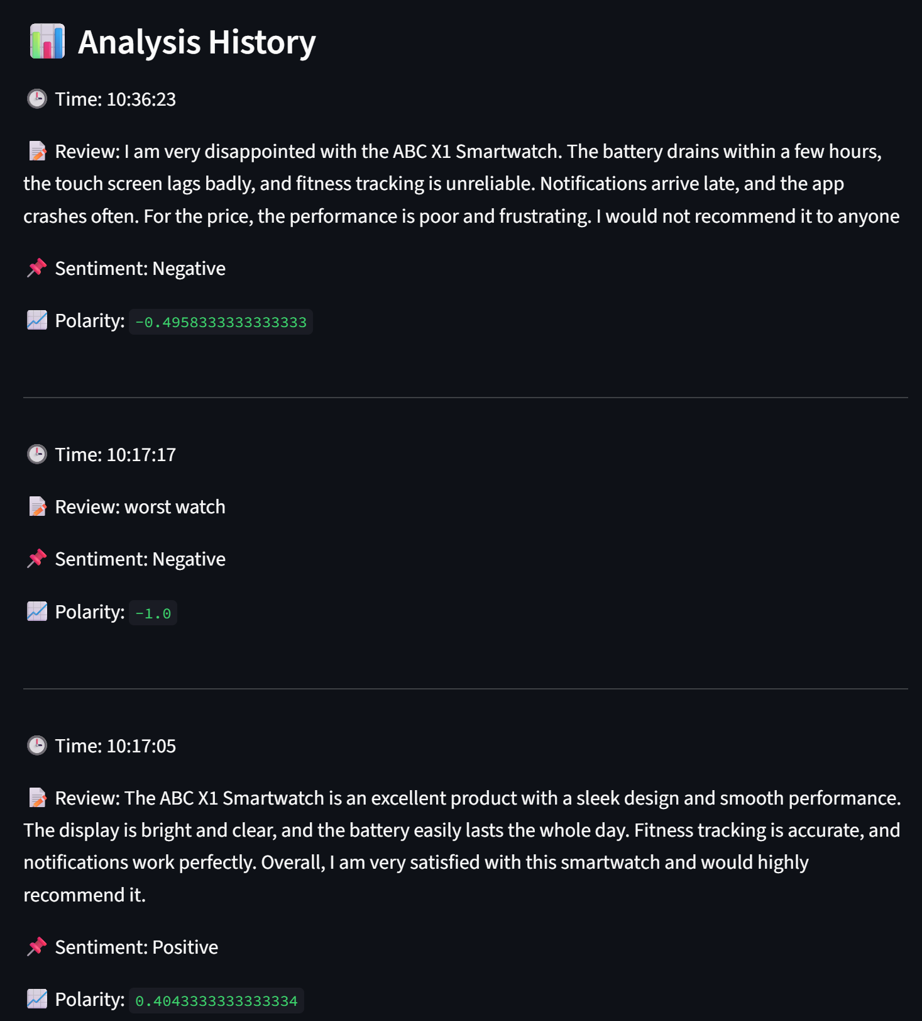

Analysis History

Future Implementations (Smartwatch Sentiment Analyzer)
Future enhancements for the Smartwatch Sentiment Analyzer focus on improving accuracy, scalability, and real-world business integration:
- E-Commerce Platform Integration:
The system can be integrated with online shopping platforms such as Amazon or Flipkart to automatically analyze customer reviews and provide real-time sentiment insights for sellers and manufacturers.
- Advanced Machine Learning Models:
In future versions, this system can be upgraded from TextBlob to advanced machine learning and deep learning models such as Naive Bayes, Logistic Regression, or Transformer-based models (BERT) to improve sentiment classification accuracy.
- Multilingual Sentiment Analysis:
The system can be enhanced to support multiple languages so that customer reviews in different regional languages can also be analyzed effectively.
- Automated Dashboard & Analytics:
A graphical dashboard can be added to show overall product sentiment trends, customer satisfaction scores, and historical sentiment comparisons for business insights.
- Mobile Application Deployment:
A mobile-based version of the Smartwatch Sentiment Analyzer can be developed to allow companies and customers to analyze feedback on the go.

Conclusion (Smartwatch Sentiment Analyzer)
The Smartwatch Sentiment Analyzer project successfully delivers a simple, efficient, and user-friendly solution for analyzing customer sentiments toward the ABC X1 Smartwatch. By utilizing Streamlit for the web interface and TextBlob for sentiment analysis, the system provides instant classification of reviews into Positive, Negative, and Neutral categories.
This project demonstrates the practical application of Natural Language Processing (NLP) in real-world business scenarios such as product evaluation, customer satisfaction monitoring, and feedback analysis. The application enables organizations to quickly understand customer opinions without manual effort, thus supporting better product improvement and decision-making.
Overall, the Smartwatch Sentiment Analyzer stands as a reliable and scalable sentiment analysis tool that bridges the gap between raw customer feedback and meaningful business insights, making it a successful and impactful mini project.

